Biology 3201 Diabetes/Benedict’s Test Lab Name: _________________

Introduction
Diabetes is a malfunction of one of the major homeostatic mechanisms in the body – the endocrine system. Two hormones, insulin and glucagon control the level of sugar in the blood. The more glucose in the blood and surrounding fluid, the greater the amount of insulin that gets produced. The insulin is produced and released by the pancreas and is used to lower the level of glucose in the blood. This is done by causing cells to uptake (remove) glucose from the blood. If insulin levels fall and blood sugar level becomes too high, glucose in the nephrons cannot be completely reabsorbed by the cells of your body, so glucose is released in the urine. One of the earliest tests for diagnosing diabetes was to taste the urine of a potential diabetic. If it was sweet, diabetes was a probable diagnosis. In this investigation you will observe data taken from various solutions to determine if the glucose levels are high. Benedict’s solution is a reagent that changes colour in the presence of glucose. Copper ions within the reagent react with glucose molecules and form cuprous oxide. Cuprous oxide gives a colour change from green to yellow to red depending on the amount of glucose present in a sample.

Type 1 Diabetes: This form of diabetes is believed to be an autoimmune disorder in which the insulin producing cells of the pancreas are destroyed. There is no insulin production practically overnight. Without insulin, the body cannot convert excess glucose to glycogen, fat to adipose tissue and protein into muscle. Also, insulin assists in the facilitated diffusion of glucose into the cell. This means the cells essentially starve. This form of diabetes is treated with insulin.

Type 2 Diabetes: This also referred to adult onset diabetes. Ninety percent of diabetics are type 2. In this case, the body produces insulin in insufficient quantities or the body cells are unable to respond to insulin normally. This type of diabetes is treated with diet and exercise. Medications and/or insulin shots may also be necessary.

Both forms of diabetes can result in weight loss, blindness and circulatory disorders. They can be diagnosed using urine analysis and/or a glucose tolerance test.

Complete the following table and lab by going to www.mrgillam.weebly.com and clicking on virtual lab under Biology 3201
Solution Colour | Approximate glucose concentration  (percentage of solution)
Blue | Negative
Light Green

Olive green
Yellow-green to green

Orange

Red brown

Table 1: Percentage of glucose in solution

Analysis Questions:
- What were the sugar concentrations for each of the samples in figure 1? (see picture at front of class) (5 Marks)

A_________________ B_________________ C_________________ D_________________
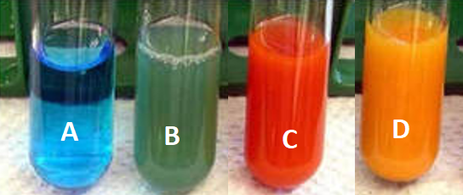
Figure 1

- Describe the chemical reaction that was responsible for changing the colour of the Benedict’s solution on the test samples. (2 Marks) Paragraph 1
____________________________________________________________________________________________________________________________________________________________________________________________________________________________________________________________________________________________________________________________________________________________________________________________________________________

- One of the symptoms of diabetes mellitus is frequent and copious urination. Explain why this occurs. (2 Marks)
____________________________________________________________________________________________________________________________________________________________________________________________________________________________________________________________________________________________________________________________________________________________________________________________________________________

- When we eat a meal. Our blood sugar level rises. How is homeostasis maintained in non-diabetic patients? How do diabetic patients deal with the increase in blood sugar? (2 Marks)
____________________________________________________________________________________________________________________________________________________________________________________________________________________________________________________________________________________________________________________________________________________________________________________________________________________

- Diabetes mellitus is also called Type 1 diabetes. Another form of diabetes, Type 2 diabetes or adult onset diabetes is more common. Describe the difference between Type 1 and Type 2 diabetes. (2 Marks)
____________________________________________________________________________________________________________________________________________________________________________________________________________________________________________________________________________________________________________________________________________________________________________________________________________________

- Explain why Type 2 diabetes can be controlled with lifestyle modification, but Type 1 diabetes cannot. (2 Marks)
____________________________________________________________________________________________________________________________________________________________________________________________________________________________________________________________________________________________________________________________________________________________________________________________________________________

- What are three side effects of both types of diabetes and how can it be detected? (2 Marks)
____________________________________________________________________________________________________________________________________________________________________________________________________________________________________________________________________________________________________________________________________________________________________________________________________________________

